SPEECH CONFIDENCE CHECKER

(Project Documentation/Guide)

Pre-Requisites:

1. A Google Account
2. Logged in Google Drive
3. Colab Pro subscription
4. Any latest browser (Chrome, Edge, Firefox, etc)

Step 1 (Opening Notebook in Colab) :

* Open Google Colab (<https://colab.research.google.com>)
* Make sure to have **Subscription** of Colab Pro (Some functions need PRO version to run).
* Inside Colab, click **File** and upload the provided notebook (TEST_Speech_Confidence_Checker.ipynb) as given below:
* 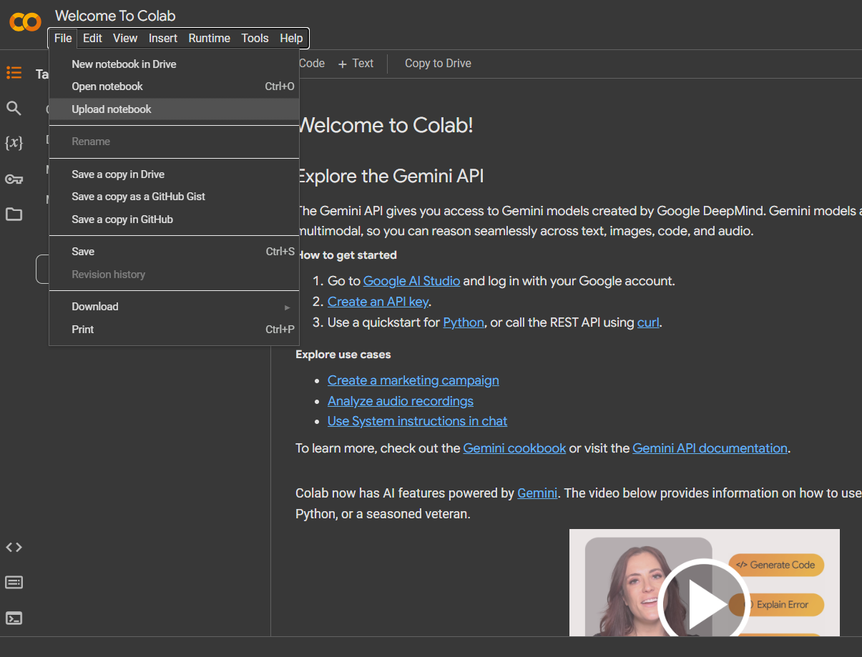

Step 2 (Connect to Runtime) :

* After the upload, the notebook is opened in colab, then find **Runtime** tab in the top bar, and click **Change Runtime Type** as given below:
* 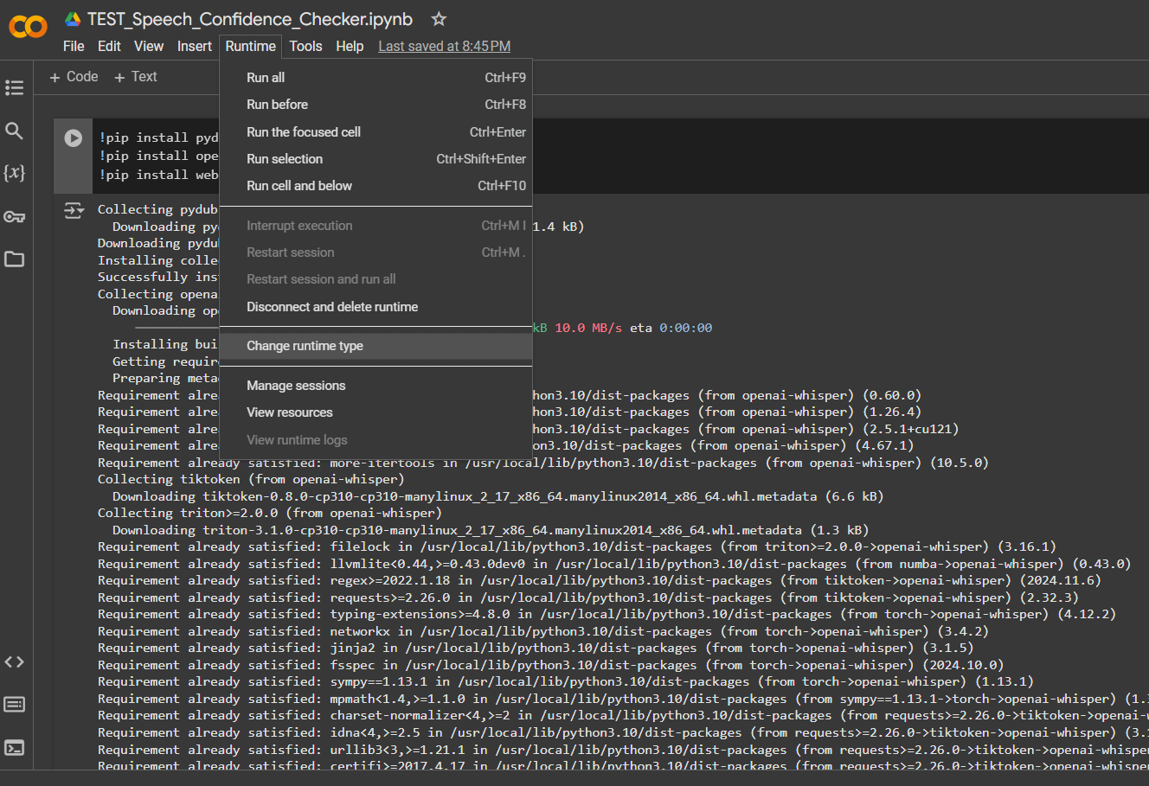
* After that, runtime popup appears as shown, select the options selected in the picture shown below, and then click **Save.**
* 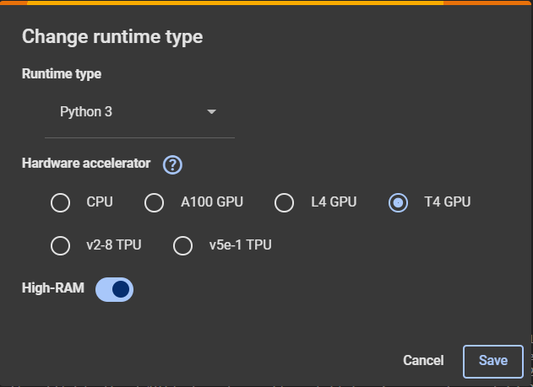

04

03

02

01

* Once you have selected the right runtime type, then just connect with the runtime by clicking **Connect** as shown. (If it automatically starts connecting, then don’t touch it).
* 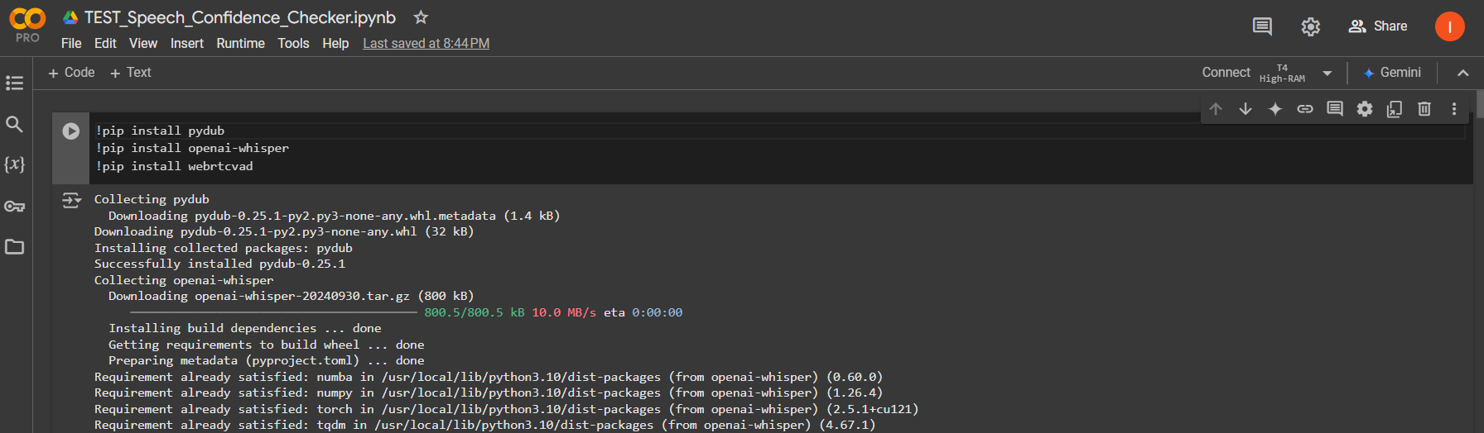

Step 3 (Mount Google Drive) :

* Click the **Folder like icon** on the left vertical bar, and mount the drive, as shown.

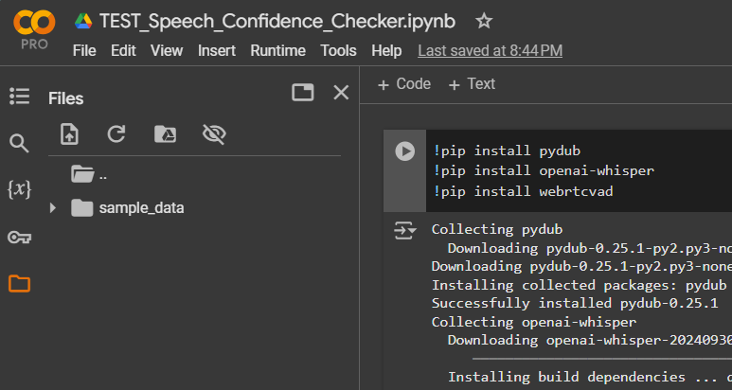

1

2

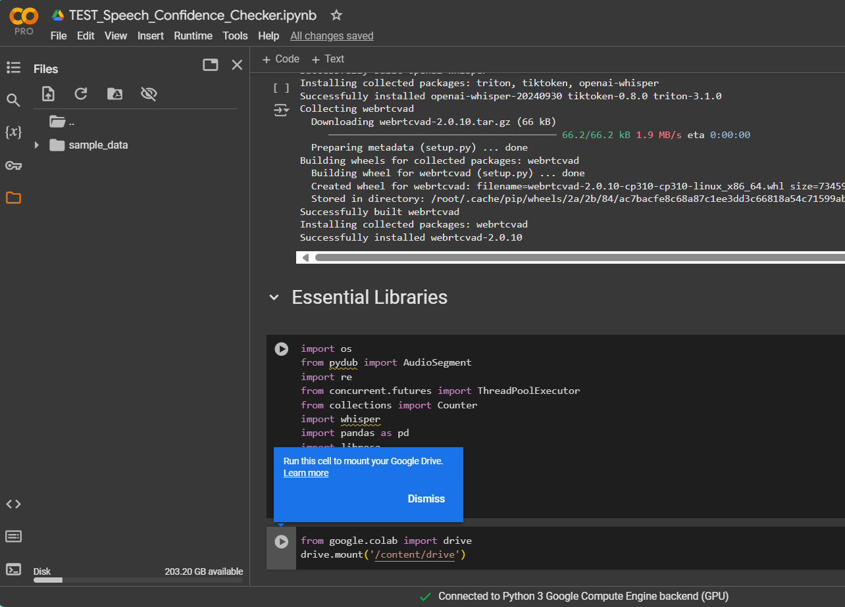

* After clicking Mount Drive icon, there can be two possibilities (1- Google Drive will be mounted. 2- A new cell will appear as shown above, you need to click the play button to run the cell, this will mount the drive.)
* After that, it will lead to a series of steps to connect to drive. You just need to follow the steps and select a relevant Google Account (an account on which you purchased the Colab Pro subscription).
* You should have your all the data in relevant Google Drive account, you are going to mount. (For Example: Google Drive -> A folder of audio to be passed -> Audio Files in it.)
* Once Google Drive is connected, it will show everything in your drive inside Colab as shown:

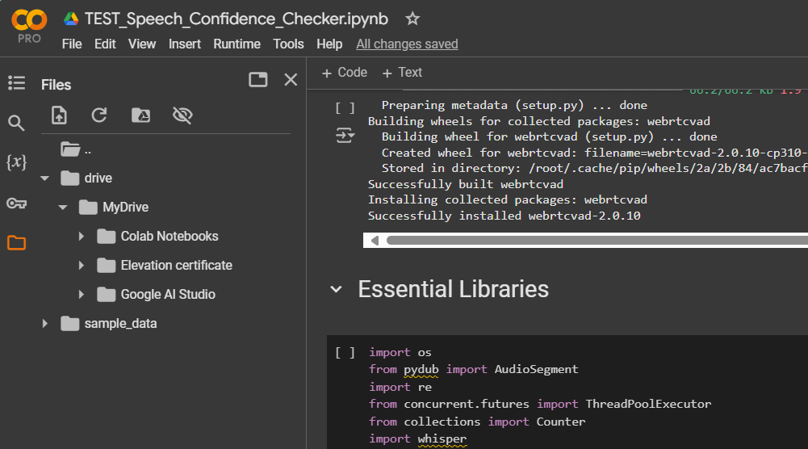

Step 4 (Run the Cells) :

* (After mounting the Drive, don’t run the cell that you ran before for mounting the drive.)
* Go to the first cell and run that, it will start installing all the essential libraries (e.g: Whisper, Pydub, and more.)
* Run the second cell renamed as **Essential Libraries,** it will import all the installed libraries, and sub-modules.
* Now go the cell renamed as **Main path to be used in complete notebook,** and inside that cell provide the directory path from your google drive, as shown:
* 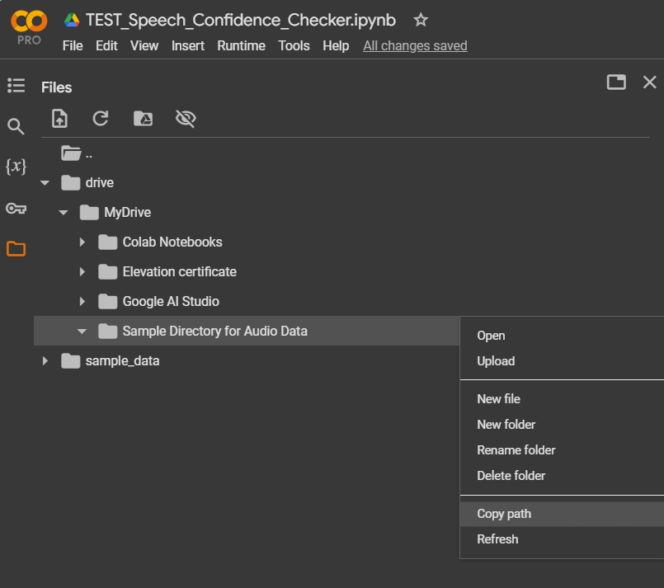

1. Copy the path
2. Right Click on the directory

* Once the path is copied, paste the path inside the double quotes of directory variable (directory = “Paste your copied path here (ctrl/cmd + V)”)
* Now, the single thing you need to do is to run each cell (by clicking the play button or by pressing Shift + Enter), and cells will show some output in the end of the cell (some may not as they are not meant for that).

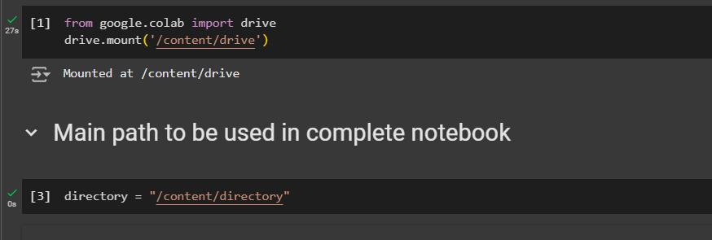

* Successful run of a cell shows a **Green Tick,**
* Unsuccessful run of a cell shows a **Red Play Button + Error message**
* Some functions are using GEMINI API for utilizing Natural Language Processing (NLP) for filler detection and Irrelevant words detection. Currently a free version of API is being used, you can purchase your own GEMINI API, and apply your API-KEY. For Gemini API visit: <https://ai.google.dev/gemini-api/docs>

* Similarly, you can change **genai.GeneativeModel(“**Select your desired model, the API supports multiple models**”)**

Step 5 (Model Preparation) :

* Run all the cells above Above **Model Preparation cell.** Run the cells before df = pd.read_csv(“directory path here.csv”).
* Inside model preparation section, you need to provide the **CSV File Path,** a csv is now available in your directory that you passed earlier.

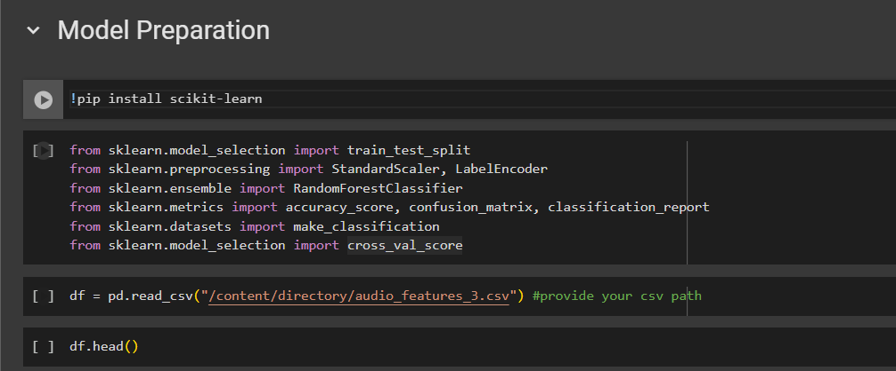

* Copy the path by **right clicking on the csv file**, and then click **Copy Path,** and paste the path inside double quotes. And keep running your cells, this will lead to the DataFrame creation, and model’s .pkl file at the end. The .pkl file will also be available in your provided directory.
* You can download your csv and .pkl file **by right-clicking** and clicking on **Download**.

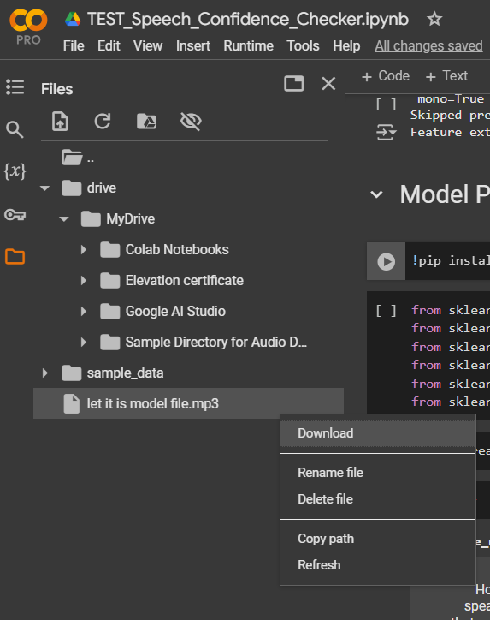

Cautions :

1. Due to change in API-Key (letting a different key on your side), the output of some functions (using that API), may vary, and before creation of .pkl file, their output may need some extra preprocessing.
2. Make sure to provide the correct directory paths.
3. Make sure to provide a directory path that contains audio files in .mp3 or .wav format.
4. A model’s accuracy totally depends on features extracted using python functions + the amount and quality of the data. In our case, we lack the data, the more the data is, more the accuracy we’ll get.